Application Number | 07/2018/1023/FUL
Address | 25 Golden Hill Lane  Leyland  Lancashire  PR25 3NP
Applicant | Phongsri Williams

Development | Change of use from hairdresser to massage shop
Officer Recommendation  Officer Name | Refusal  Mrs Debbie Roberts

Date application valid | 15.03.2018
Target Determination Date | 10.05.2018
Extension of Time | 04.06.2018

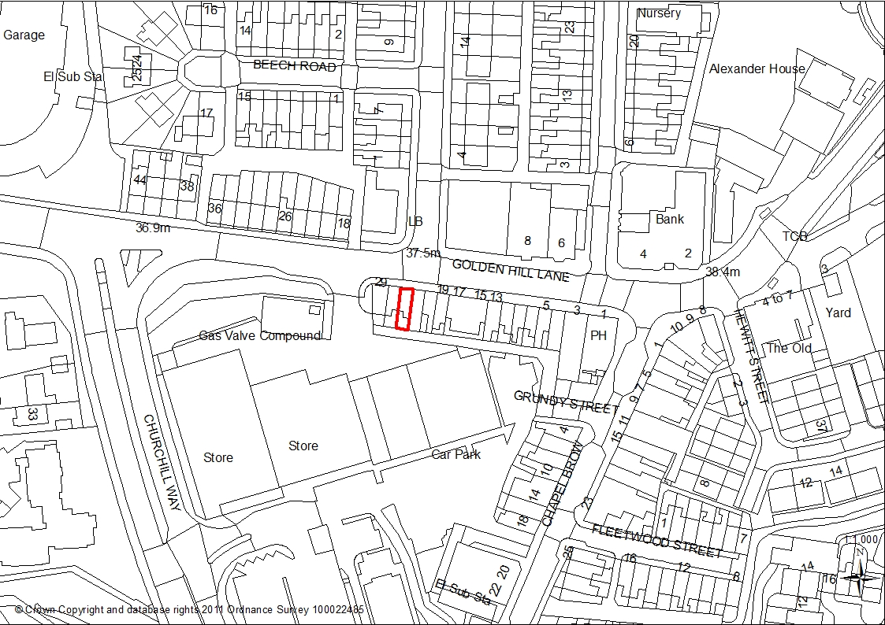

- Introduction

  - This application is brought before Committee at the request of the Ward Councillor

- Report Summary

  - The application seeks permission to change the use of former A1 retail premises to Traditional Thai Massage shop (class Sui Generis) with only internal cosmetic works. Premises would be used between 10am and 10pm Monday to Saturday, and one full time therapist would be employed.

  - Proposed development is not considered to have an undue impact on the amenity of neighbouring properties, the appearance of the area or highways safety and capacity.

  - It is the Officers view however that loss of an established retail unit within a designated retail frontage would reduce Leyland’s shopping offer to an unacceptable level, and that in such terms the proposal does not comply with either Local Plan Policy E3 (Leyland Town Centre) or the South Ribble Retail Position Statement.

  - At the time of writing this report and following full consultation representation has not been made. Late comments will be reported verbally at committee. Statutory consultee comments have been addressed by condition to be imposed should permission be granted.

  - Having regard to the above comments, this proposal is recommended for refusal on the following grounds:

‘The proposal would see the loss of an existing retail premises, and subsequent reduction of retail units to an unacceptable level within Leyland Town Centre. It is therefore contrary to Policy E3 (Leyland Town Centre) of the South Ribble Local Plan 2012-2026 and South Ribble Retail Position Statement (Nov 2017)’

- Application Site and Surrounding Area

3.1 The application refers to no: 25 Golden Hill Lane; a small, mid terrace, commercial property within the Secondary Retail Area of Leyland Town Centre, and to which Policy E3 (Leyland Town Centre) refers.

3.2 To the rear is Churchill Way Retail Park, whilst on all other sides there is a mix of commercial, retail and residential premises. Parking in this area is predominantly on-road, although a short distance to the north-east and south there are public car parks.

- Site Context / Planning History

  - There is no formal planning history for this site. The property has been in unlawful B1 (Holistic Care employment agency) for almost 12 months, but was used as a hairdressers (A1 Class) between 2001 and 2016. As such A1 is the lawful use

- Proposal

5.1 The application proposes change of use from hairdressers (use class A1) to traditional Thai massage shop (Sui-Generis use class).

5.2 The ‘Golden Thai Massage’ massage shop would operate between 10am and 10pm Monday to Saturday, but would be closed on Sundays and Bank Holidays. It would employ one full time therapist providing traditional Thai, relaxing oil and sports massage.

5.3 Internally, some minor alterations to provide therapy and shower space would be made, but otherwise the building would remain the same. Advertisement consent has been mentioned within the applicant’s statement but would be fully addressed following determination of this application if necessary.

5.4 Although properties within the terrace have the potential for residential use at first floor, only no: 27 (adjacent west) is occupied.

- Representations

  - Summary of Publicity

    - A site notice has been posted, and 8 neighbouring properties consulted. Ward Councillors Jones have also been notified.

  - Letters of Objection or Support

    - None received

- Summary of Responses

7.1 South Ribble Economic Development have concerns as to the loss of an A1 unit in this location. Their response states that ‘a considerable amount of work is in progress to support the viability of the town centre as a shopping centre for visitors, and the erosion of A1 use is a threat to the continued attractiveness of the town centre to visitors. The area in question is currently developing an attractive food and drink offer which will help the evening economy, and which also helps to link the different areas of Leyland together. We do not consider the proposed use would be appropriate to the retail and eating out offer we are attempting to develop for Leyland. We therefore object to this proposal’

7.2 South Ribble Environmental Health notes that whilst the area is obviously in use until late at night, this is currently at ground floor level. Use of the first floor until 10pm would have the potential for noise to impact upon residents through party walls. As such, a condition to restrict access to the ground floor for visiting members of the public is considered necessary should permission be granted.

- Material Considerations

8.1 Site Allocation / Retail Position

8.1.1 The application site sits within Leyland Town Centre (secondary retail frontage) as allocated by Local Plan Policy E3 (Town Centre)

8.1.2 The overarching theme of the National Planning Policy Framework is one of presumption in favour of sustainable development; this includes building a strong and competitive economy with Paragraph 23 stating that ‘local planning authorities should promote competitive town centres which provide … a diverse retail offer’.

8.1.3 Local Plan Policy E3 (Leyland Town Centre) similarly seeks to protect and prioritise retention of A1 (retail), A3 (café & restaurant) and A4 (Drinking Establishments) but does recognise that an element of A5 (take away) use might be acceptable where it does not detract from the primary retail function of the area. This ‘A’ class protection is particularly tight within the secondary retail frontage

8.1.4 The South Ribble Retail Position Statement states that ‘the introduction of significant numbers of non-retail uses into town centres … such as banks, building societies and other professional activities, can introduce breaks in the continuity of retail frontages. These ‘dead frontages’ can be visually disruptive and may be discouraging to shoppers. They can also reduce the choice of units available to retailers, fragmenting and weakening the established shopping centres and making them less vibrant places’. This document seeks to maintain a minimum of 60% of A1/A3/A4 retail uses in all the identified town, district and local centres’. It also notes that ‘in the secondary retail frontage, changes for uses other than A1, A3 and A4 should be accompanied by a 6 month marketing assessment to provide evidence for this change of use’.

8.1.5 The latest Retail Position Statement (Nov 2017) identifies 48% of A1/A3/A4 uses, and an additional 6% vacancy rate with retail use potential across the whole Town Centre (primary and secondary frontages). A survey of the Secondary frontage (4th April 2018) in the northern (immediate) area however identifies only 36% in retail use with the remaining 64% occupied by uses which would normally be less appropriate in a retail setting (A5 (hot food takeaways, Class D1 (veterinary) and Sui Generis (tattoo parlour). A check of the extended Secondary area also shows a percentage of 51.5% - again below the 60% standard requirement. As neither Secondary frontage nor Town Centre as a whole can achieve the 60% retail use described above, the loss of an A1 unit to alternative use does not comply with either Policy E3 or the Retail Position Statement, and is considered of detriment to Leyland’s retail offer.

8.1.6 Despite its town centre allocation, Golden Hill Lane is a less accessible part of the retail centre, and proposed changes might have brought an element of positive diversification to an unused building. Premises have only been empty however since December 2017, and the applicant has not submitted any marketing assessment to show a lack of interest for genuine retail use. Use of the property for non-retail use therefore is not considered essential to maintain the vitality and viability of Leyland town centre as a whole, and by reducing the shopping offer, is likely to also reduce footfall to an already struggling area.

8.2 Parking

8.2.1 Local Plan Policy F1 (Parking Standards) requires that all development provides adequate off road parking which corresponds to adopted standards. Although off road parking is limited, this is not unusual in the area. Properties benefit from available on road and ‘pay and display’ parking in line with Local Plan Policy E3 (Leyland Town Centre) which states that ‘new use in the town centre will either be expected to use existing parking facilities or provide appropriate levels of car parking’. As the premises are on a sustainable bus route, within easy reach of the railway station and will differ little in terms of design or potential opening hours, the proposal in highways safety and capacity terms is considered acceptable.

  - Design, Character, Appearance and Impact Upon Neighbouring Properties

8.3.1 Site Allocations Policy G17 (Design Criteria for new development) seeks to ensure new development relates well to neighbouring buildings and the extended locality, is of a high quality and respects local character and distinctiveness.

8.3.2 Proposed use of the unit would not be dissimilar to previous uses, and as such additional detrimental impact upon neighbouring residents is not anticipated. Although all properties within the terrace have the potential for residential use at first floor, only no 27 (adjacent west) is occupied. The external appearance would also remain the same other than potential advertisement changes which would be broached at a later date should permission be granted for this proposal.

8.3.3 Concerns have been raised verbally that the proposed use would not be acceptable within the vicinity of residential properties, or in such a visible location. A decision should be based however on the merits – or not – of a massage shop in the Town Centre in policy terms, and not upon conjecture or hearsay.

- Conclusion

  - Having regard to the above comments, this proposal for change of use of former hairdressers (A1 use) to Traditional Thai Massage Shop (Sui Generis Class) does not comply with either Local Plan Policy E3 or the South Ribble Retail Position Statement 2017. The applicant has not demonstrated that the property could not be let for genuine retail purposes over a 6 month period, and the proposed change of use would result in the loss of a retail unit in a designated retail frontage to the detriment of the shopping offer as a whole. The application therefore is recommended for refusal on the following grounds:

‘The proposal would see the loss of an existing retail premises, and subsequent reduction of retail units to an unacceptable level within Leyland Town Centre. It is therefore contrary to Policy E3 (Leyland Town Centre) of the South Ribble Local Plan 2012-2026 and South Ribble Retail Position Statement (Nov 2017)’

RECOMMENDATION:

Refusal.

REASONS FOR REFUSAL:

1. The proposal would see the loss of an existing retail premises, and subsequent reduction of retail units to an unacceptable level within Leyland Town Centre. It is therefore contrary to Policy E3 (Leyland Town Centre) of the South Ribble Local Plan 2012-2026 and South Ribble Retail Position Statement (Nov 2017)

RELEVANT POLICY

NPPF National Planning Policy Framework

South Ribble Local Plan
E3 Leyland Town Centre
F1 Car Parking
G17 Design Criteria for New Development

